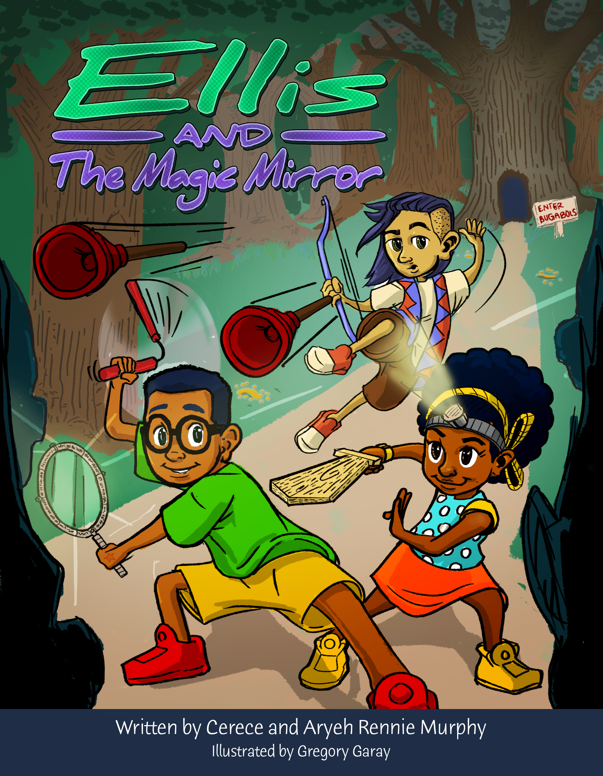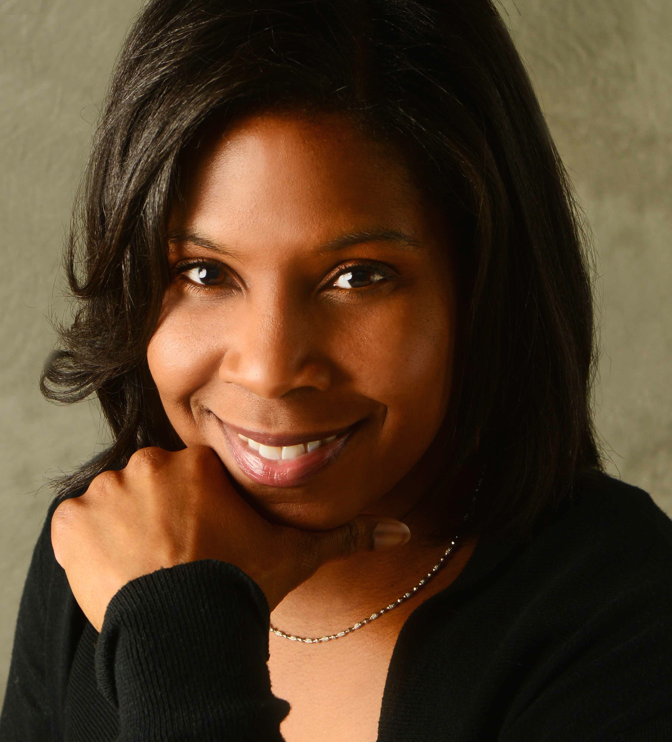

**Join Ellis, Freddye and Toro on an adventure you will never forget……**

“Delightful and unexpected. Young readers will thoroughly enjoy this book.” – Tanya Barnett, Founder and CEO, Forever Free Books

“The story kept my children waiting for more with every chapter. They really enjoyed it.” – E. Mitchell, mother of a 2

Ellis Monroe has always been curious about the world. When his father brings home an ancient mirror with the power to reveal the truth about the people and things around him, Ellis begins to see the world in a whole new way.

But things get more than a little strange when Ellis takes the mirror to school. While playing with it on the playground with his best friend, Toro Quispe, Ellis discovers that someone – or something – is hiding out at Harriet Tubman Elementary and trying to stop children from learning. Determined to solve the new mystery, Ellis, Toro, and his little sister, Freddye go on a secret mission to find out the truth about the troublesome Buddy Cruster and stop whatever he and his friends have planned.

Ellis and The Magic Mirror will be released in hardcover and paperback on August 18, 2015.

“The vocabulary and reading levels are very appropriate for second and third grade readers.  The...plot is great [and] kept my attention.  I also like that the main characters are African-American children dealing with normal…lives.  I have struggled to find books with African-American characters who are not stereotyped or set in a time period of racial struggle…great job!!! .” – M. Erb, 2nd Grade Teacher

**Book Order Information for Ellis and The Magic Mirror by Cerece Rennie Murphy:**

Publisher: LionSky Publishing – Retail Price: $9.99 (Softcover), $17.99 (Hardcover) – Distributor: Ingram Book Group – Discount Rate: 55% - Returnable: Yes – ISBN: 9780985621056 (Paperback), 9780985621063 (Hardcover)

#### A

#### B

#### D

#### C

**Next Projects:**

In addition to working on the next book in the “Ellis Monroe Series”, Ms. Murphy is currently developing a love story inspired by the classic movie Somewhere in Time and a 2-part science fiction thriller set in outer space. To learn more about the author and her upcoming projects, please visit her website at [www.cerecerenniemurphy.com](http://www.cerecerenniemurphy.com). Review copies of current titles are available upon request.

Cerece Rennie Murphy fell in love with science fiction at the age of seven, watching “Empire Strikes Back” at the Uptown Theater in Washington, D.C., with her sister and mom. It’s a love affair that has grown ever since. As an ardent fan of John Donne, Alice Walker, Kurt Vonnegut and Alexander Pope from an early age, Cerece began exploring her own creative writing through poetry.

She earned her master’s degrees in social work and international relations at Boston College and Johns Hopkins School for Advance International Studies, respectively, and built a rewarding 15-year career in program development, management and fundraising in the community and international development arenas – all while appreciating the stories of human connection told in science fiction through works like Octavia Butler’s “Wild Seed,” Frank Herbert’s “Dune” and “The X-Files.”

In 2011, Cerece experienced her own supernatural event - a vision of her first science fiction story. Shortly after, she began writing what would become the best-selling Order of the Seers trilogy. Order of the Seers was selected as one of [The Best Kindle Books of 2014 by Digital Book Today](http://digitalbooktoday.com/2014/12/24/best-kindle-books-2014-selected-weekly-featured-great-reads-part-5/).

Cerece lives in her hometown of Washington, D.C., with her husband, two children and the family dog, Yoda.

# Author Bio

#### A

#### B

#### D

#### C